**Ansh Ranjan**

**Azure Data**

**EXERCISE 2 - Introduction to Azure Databases**

**TASK 1: Deploy a sample database in Azure Cosmos DB and Azure SQL Database**

* **SQL DATABASE**

1. Go to SQL Databases > Create > Enter details > Create a new database server if you do not have existing option.    
   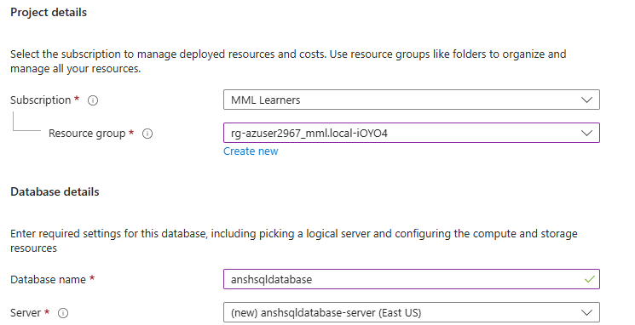
2. Under Network tab set Admin login and Password for your SQL database  
   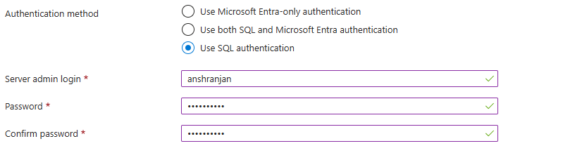
3. Picking serverless computer for cheaper computation   
   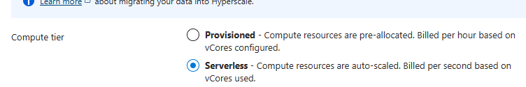
4. Under Network settings, allow connection to database   
   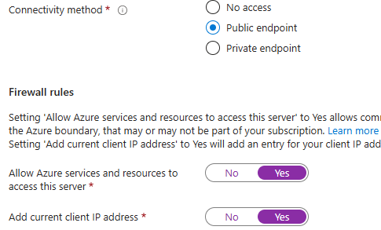

* **COSMOS DB MONGO DB**

1. Open Cosmos DB > Create > Cozmos DB for MongoDB   
   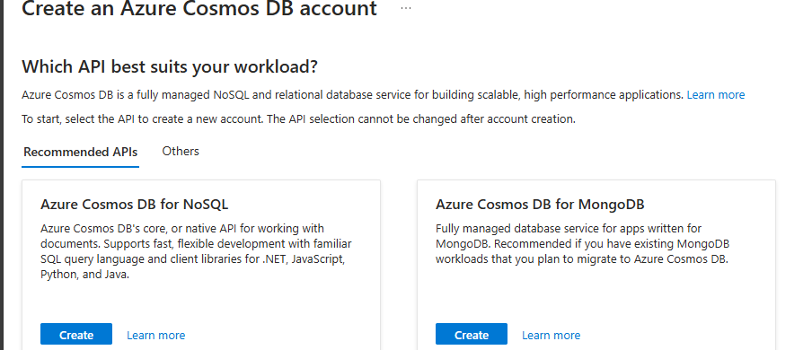
2. Request Unit database account > Enter details > Review and Create   
   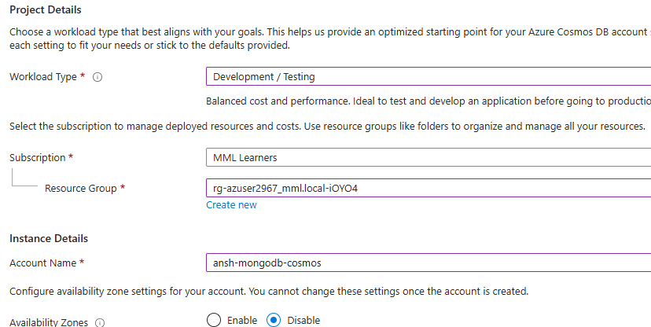
3. Your Azure Cosmos DB API for Mongo DB will be created and running   
   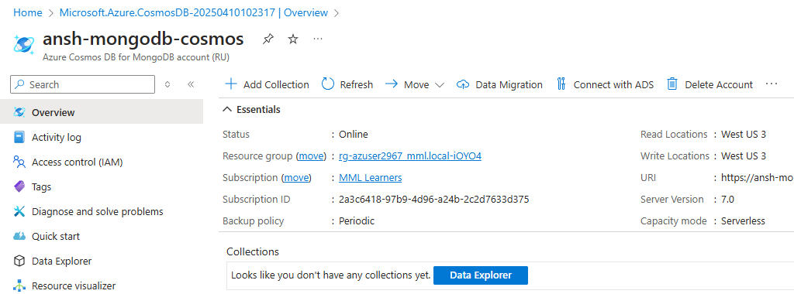

**TASK 2: Document key features and use cases for each**

**Azure Synapse Analytics**

**Key Features**:

* Unified platform for big data and data warehousing.
* Massively Parallel Processing (MPP) for large datasets.
* Integrated pipelines for ETL/ELT with Azure Data Factory.
* Synapse Studio for data exploration and analytics.
* Scalable, secure, and supports machine learning.

**Use Cases**:

* Data warehousing and big data analytics.
* Business intelligence with Power BI integration.
* Advanced analytics and IoT data processing.

**Azure SQL Database**

**Key Features**:

* Fully managed relational database service.
* High availability, scalability, and automated maintenance.
* Elastic pools for resource sharing.
* Advanced security and geo-replication.
* Seamless integration with other Azure services.

**Use Cases**:

* Transactional workloads (OLTP).
* Backend for web/mobile apps and e-commerce systems.
* ERP/CRM databases and lightweight analytics.

**Comparison of Use Cases**

|  |  |  |
| --- | --- | --- |
| **Feature/Use Case** | **Azure Synapse Analytics** | **Azure SQL Database** |
| **Primary Focus** | Analytical workloads (OLAP) | Transactional workloads (OLTP) |
| **Data Volume** | Petabytes of data | Gigabytes to terabytes of data |
| **Scalability** | Massively parallel processing | Elastic scaling for transactional data |
| **Integration** | Big data tools, Power BI, Data Lake | Web apps, mobile apps, and business apps |
| **Machine Learning** | Advanced analytics and AI workloads | Limited to lightweight analytics |
| **Use Case Examples** | Data warehousing, predictive analytics | E-commerce systems, ERP/CRM databases |

**TASK 3: Perform basic CRUD operations**

* **SQL DATABASE**

1. Go to your DB > Query Editor > Login with admin ID and password
2. You will be presented with query page. Write a query to create a table in your database   
   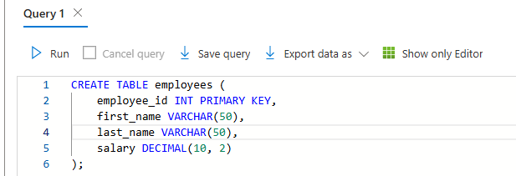
3. Insert records into your database table and read them   
   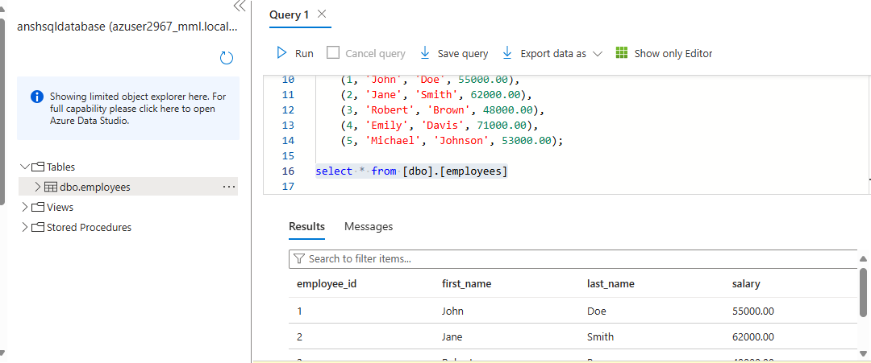
4. Updating and Deleting records   
   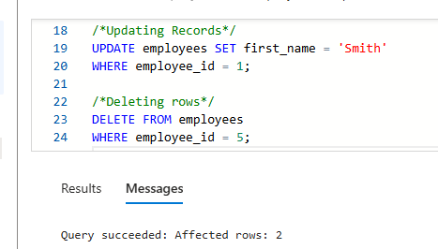

* **COSMOS DB MONGO DB**

1. Go to Data Explorer > Create Database > New Collection > Select Database or create new, give collection id, shard key   
   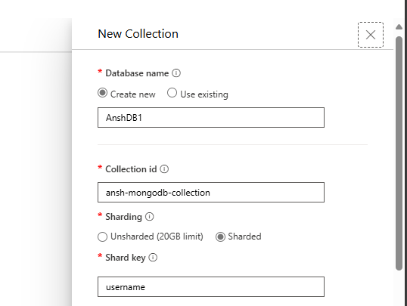
2. Once your collection is created > click New Document and enter data in document > Save   
   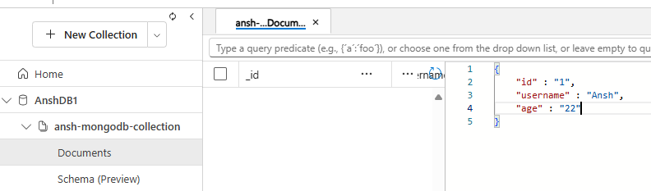
3. You can add more documents now that your mongo db is up and running   
   